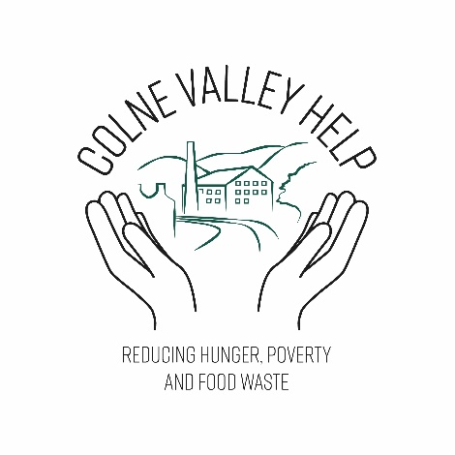

**Colne Valley Help**

**Aims and Objectives**

Nov 2021

Review date before: 21/11/22

**Colne Valley Help – Aims and Objectives**

**Our Vision**

To make a positive difference to the well-being of children and young people, families and individuals living in the Colne Valley and to help our community thrive

**Our Values**

To act with integrity and discretion in everything that we do

To show generosity without judgement

To treat people in need with dignity and respect

**Our Aims**

To prevent and relieve poverty and deprivation in the Colne Valley

To facilitate access to affordable food, help and signpost for people that need support

To enable people to access well-being support and advice services

To respond promptly to need

To harness the good will of our community to assist those that need it by donating money, food, consumables or time to pass on or sell items

To provide opportunities for volunteers to engage with and contribute to our community

To campaign and lobby to help to reduce deprivation and the need for welfare

To actively participate in support networks that seek to improve the well being of people in Kirklees

Date reviewed: 22/11/21