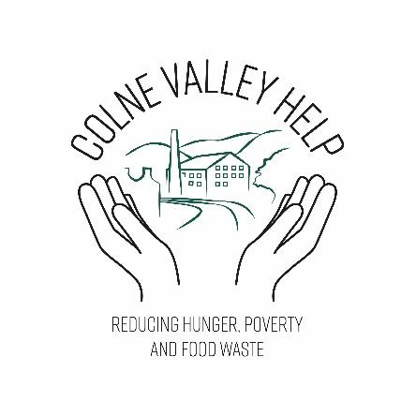 BECOME A FRIEND OF COLNE VALLEY HELP

Every week we help more than 45 households in the Colne Valley and Golcar by providing them with fresh food, pantry staples, toiletries and household cleaning products from our foodshare bases in Slaithwaite Fire Station and at the Golcar Drop By Centre.

Since last Autumn the number of households using our service has almost doubled and shows no sign of decreasing any time soon. At times of particular need, for example during the winter, at Christmas and around school holidays, we help significantly more people and their families.

By becoming a Friend of CVH you can help us to continue this essential support. The people who use our services make a small donation if they can afford it. We apply for charitable funds and have food donation stations in Slaithwaite and Marsden. However, all of these sources combined do not provide us with sufficient income or food to meet the need, nor do they provide a regular income stream.

We are seeking Friends to contribute in a number of ways
- Make a monthly donation of £5/£10
- Be available to volunteer when we need extra help. For example, at Christmas when we make extra hampers for users or helping us to staff an information stall at an event

In return we will
- With your consent, include your name in the list of our supporters on our website
- Invite you to an annual event to mark the years activities
- Keep you up to date with our news

If you would like to become a Friend of Colne Valley Help please provide your details below (all information will be used in accordance with our GDPR policy which is published on our website www.colnevalleyhelp.org.uk)

Please set up your regular Standing Order payment to Account name: Colne Valley Help, Account number 70700036, Sort code 53-61-07

Boost your donation by 25p of Gift Aid for every £1 you donate. Gift Aid is reclaimed by the charity from the tax you pay for the current tax year.

Please submit your form by email to: colnevalleyhelp@outlook.com

By post to: Colne Valley Help c/o Slaithwaite Fire Station, New Street, Slaithwaite, HD7 5AB

Friends of Colne Valley Help

Please insert tick ( ✓ ) in boxes below, where appropriate.

I would like to be a Friend of CVH

I have set up a monthly donation of £5/£10 (reference: CVH – your name or initials)

I am happy to be contacted if you need help from time to time.

I consent to my name being included on the list of supporters on your website

Your address is needed to identify you as a current UK taxpayer. In order to Gift Aid your donation you must tick the box below:

I want to Gift Aid my donation of £5/£10 and any donations I make in the future or have made in the past 4 years to Colne Valley Help

I am a UK taxpayer and understand that if I pay less Income Tax and/or Capital Gains Tax than the amount of Gift Aid claimed on all my donations in that tax year it is my responsibility to pay any difference.

My Details

Title First name or initial(s)

Surname

Full Home address

Email address

Postcode Date

Please notify the charity if you:

∙ want to cancel this declaration

∙ change your name or home address

∙ no longer pay sufficient tax on your income and/or capital gains

If you pay Income Tax at the higher or additional rate and want to receive the additional tax relief due to you, you must include all your Gift Aid donations on your Self-Assessment tax return or ask HM Revenue and Customs to adjust your tax code.

